WIZnet iEthernet Design Contest 2007
Entry number 001185
Chuck Baird, service <at> cbaird.net

Complete Documentation

Terminalator II – The SQL

Introduction
This project (001185) uses a WIZnet WIZ810MJ board and an Atmel AVR Butterfly development board to connect a PC host server application to a “dumb” ASCII terminal. The user at the terminal types SQL commands which are then applied to a Microsoft Access database, and the results are displayed on the terminal.
This is not meant to be a practical solution, but rather a proof of concept for a simple and low cost TCP interface to server software. This example uses RS-232 to the terminal device and communicates bidirectionally with the server, with a modest amount of processing done by the embedded MCU driving the WIZ810MJ.
The AVR Butterfly is based on an 8MHz ATmega169 MCU with 16K flash, 2K SRAM, 512 bytes EEPROM, 4MB dataflash, 6 character LCD, joystick, RS-232 level converters, and other peripherals. The LCD is used to display limited status information about the ethernet connection, although it provides no real purpose here other than a high cuteness factor. The WIZ810MJ board is accessed using its SPI mode, given the Butterfly has an SPI header readily available and a shortage of available I/O pins. The resources of the ATmega169, and the Butterfly itself, are barely utilized.
When the Butterfly is powered on or reset it attempts to initialize the WIZnet board and make a client connection to the already running host software using a hardcoded (in this version) IP address. Once the connection is made, the user is prompted to type SQL statements on the terminal. These statements are buffered until a carriage return is seen, and minor editing is supported (ESC to discard a line, and backspace). The completed input line is sent to the host, and most are passed directly to the database. Safety nets are in short supply in this demo.
The Atmel AVR Butterfly was chosen because of its power, low price (under $25), and complement of existing support circuitry, thus allowing the entire project to be constructed from off the shelf components and a wiring harness. However, because of design consistency across the AVR product line, the project could easily be ported to the majority of the AVR microcontrollers with very minimal changes to the software.

Commands
The user commands (typed at the terminal) are:
open – open a predesignated Microsoft Access database
close – close the database, terminate the TCP connection, and shut down the server software. Also quit, stop, and end will do the same.
select... – SQL select statements are executed and the resulting dataset is returned as multiple line ASCII text in the format [field] = value.
all else – any other input is assumed to be an SQL action statement and is handed off to the database engine for execution.

Examples
A sample terminal dialog is shown in the Figure 1 screen capture. Since this is written for a dumb terminal, HyperTerminal is a most appropriate choice. The terminal or emulation only needs to support the backspace character.
“Goodstuff” is the name of a table in the database, and the field names (and values) are shown following the select statement. An update (SQL action statement) is executed and the results shown.

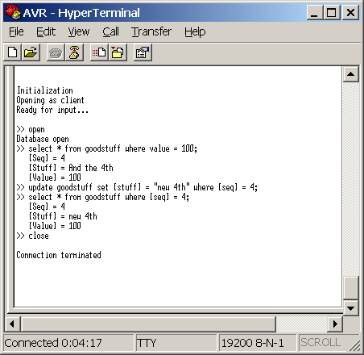
Fig 1. User interaction at the terminal

Meanwhile the server side screen shot is as follows:

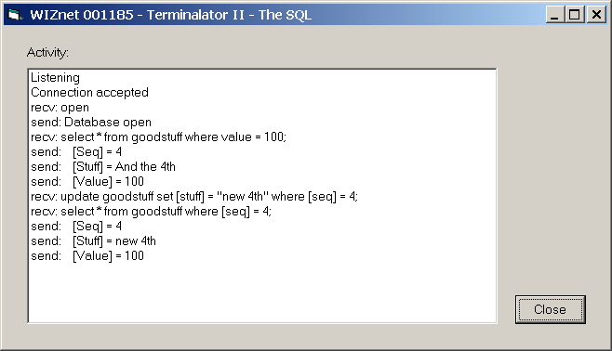
Fig 2. Server software

Although this particular example relies on the server closing the TCP connection (in response to the user entering a Quit command), the client software (MCU) is also capable of shutting down the connection gracefully as well.

Block Diagram
Because of the slightly unusual spacing of the header pins (2 mm) on the WIZ810MJ, an inexpensive SPI breakout board was purchased from www.nkcelectronics.com. This board, fully populated, also provided a reset switch, power LED, and LEDs for the 5 status signals, all with pullup resistors. The SPI and other signals are brought out to a more convenient 0.1” header.
In addition, the board has support for an internal pullup to Vcc for the WIZ810MJ’s SPI_EN pin. For this project this resistor was included, although a WIZnet errata sheet specified that to share the SPI bus the SPI_EN line needs to be under the control of the MCU. Consequently the Butterfly’s on board 4MB dataflash memory, an SPI device, cannot be used without additional modification to the breakout board hardware. It was not needed here, but the modifications to use it are simple.

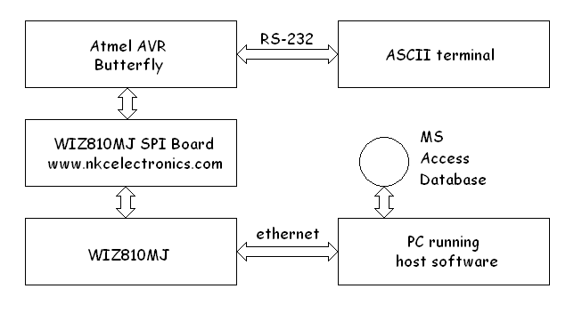
Fig 3. Block diagram

Photograph
The photograph shows the commercial components luxuriously mounted to prevent electrical shorts and to facilitate handling. The wiring harness extends below the visible surface.
The 6 pin header in the Butterfly’s lower right corner is both its SPI and programming header (AVRs use the SPI pins for one of several methods of programming). To program the Butterfly with this application this connector is temporarily replaced with one to the programming hardware. An Atmel STK500 programmer was used, although many alternatives exist.

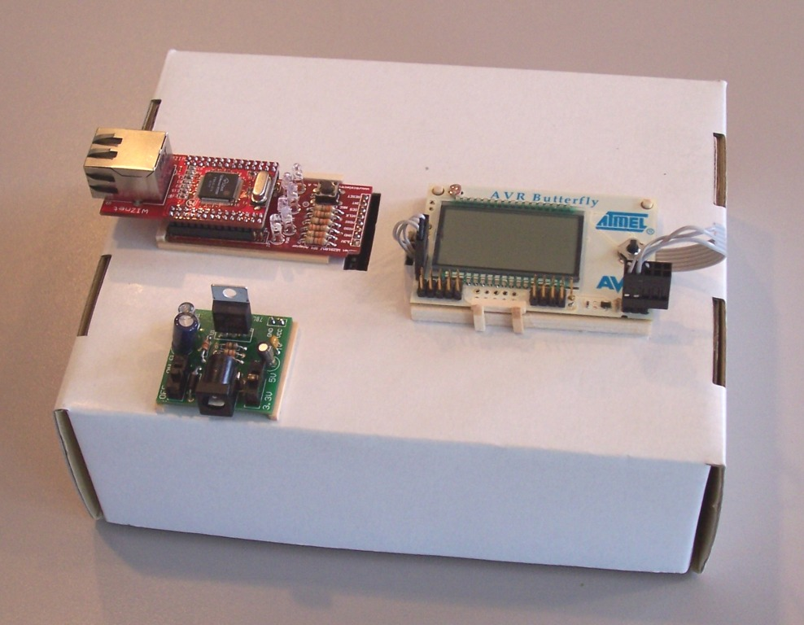
Fig 4. Yet another use for recycled cardboard

Fig. 4 clockwise, from upper left: WIZ810MJ (on top) plugged into the breakout/carrier (bottom) board, the Atmel AVR Butterfly, and the Sparkfun Breadboard Power Supply. The RS-232 connection to the terminal is in the rear and not visible.

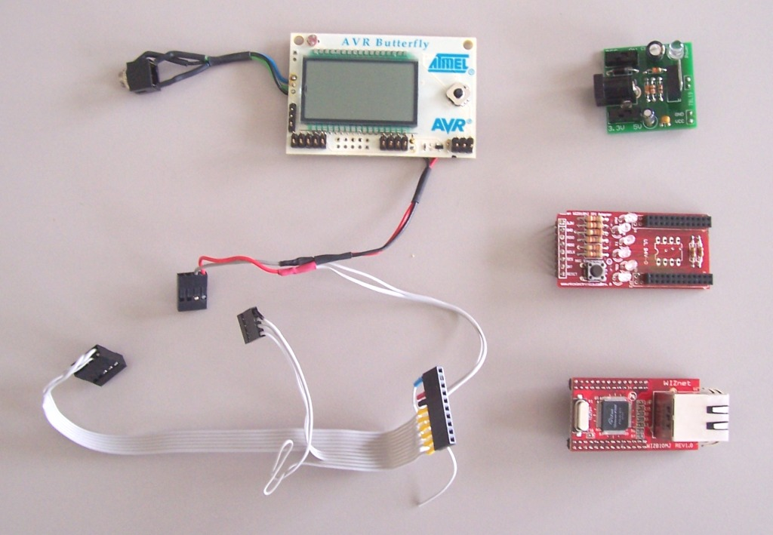
Fig 5. Parts is parts

Schematic
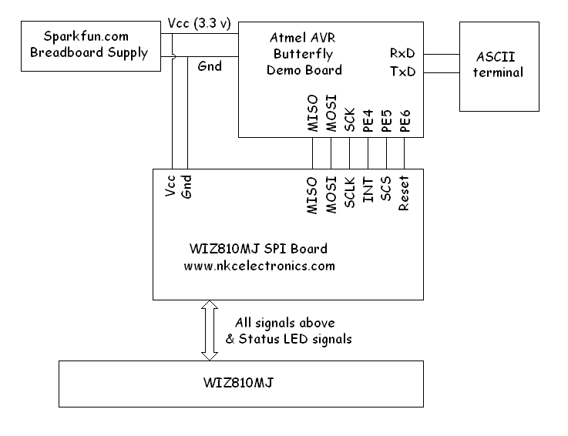
Fig 6. Schematic

Software Code
Assembly language was used in the AVR because the author is a masochist. With the exception of the LCD segment layout table, all code is original, although pieces have been borrowed from other of the author’s projects (some published), including another WIZnet iEthernet Design Contest entry. There is one main file and two subordinate files. Again, the LCD support (the first subordinate file, plus a few calls) could be omitted without adversely affecting this project.
The assembler used was the (free) Atmel AVR Studio 4, which also contains the programmer interface for the STK500 board (and others).
Visual Basic 6 was used for the PC host software.
Interrupts on the WIZ810MJ were not used, and all communications was conducted through polled monitoring of the status byte. Polling adds some overhead, but this application uses such a tiny fraction of the available computing power that it was irrelevant. The W5100 interrupt signal is routed to the Butterfly but not configured or utilized.

Summary
This was an interesting project with a few unexpected twists and turns, but overall the development went smoothly. All development was done from the W5100 and WIZ810MJ datasheets, without reference to other existing code examples. In hindsight this was probably a mistake, as some lessons could probably have been learned more easily.
The datasheet could benefit from a slight rewrite to bring it into more standard English and add a few example code snippets, but overall it was satisfactory.
As was mentioned earler, this is not meant to be a practical application, but merely an exercise in learning about the W5100 and using it in an application that makes use of some of its common features. In that regard this entire process of development was a huge success.

AVR assembly language client software (Butterfly)

; ------------------------------------------------------
; File name: WIZnet_001185.asm
;
; Project Title: "Terminalator II - The SQL"
;

The code has been omitted to make this word document a nicer size.

Visual Basic server software (PC)

' WIZnet Contest Entry: 001185
' Terminalator II - The SQL
'
The code has been omitted to make this word document a nicer size.

